Name:- Nilesh Raj
Gmail:- nileshraji811001@gmail.com

Exercise 1: Implementing the Singleton Pattern
Scenario:
You need to ensure that a logging utility class in your application has only one instance throughout the application lifecycle to ensure consistent logging.
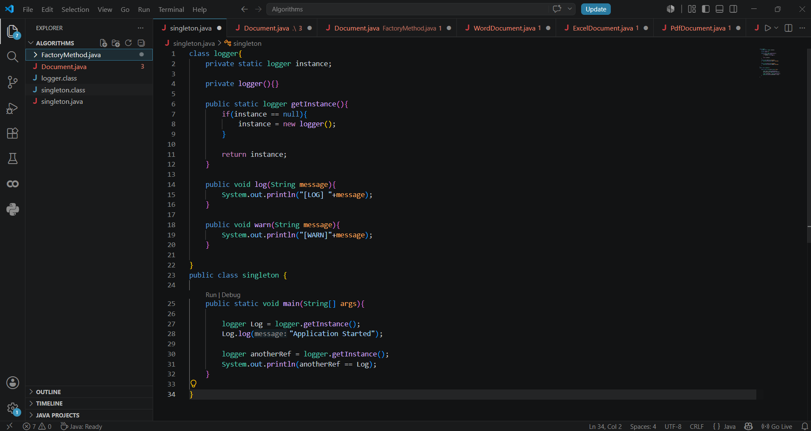
OUTPUT:
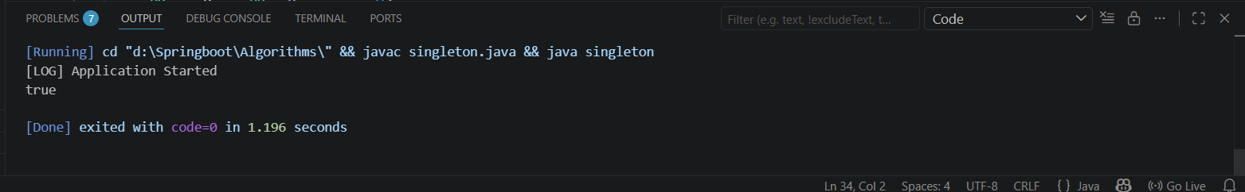

Exercise 2: Implementing the Factory Method Pattern
Scenario:
You are developing a document management system that needs to create different types of documents (e.g., Word, PDF, Excel). Use the Factory Method Pattern to achieve this.

1.Creating Doument interface and Document factory abstract class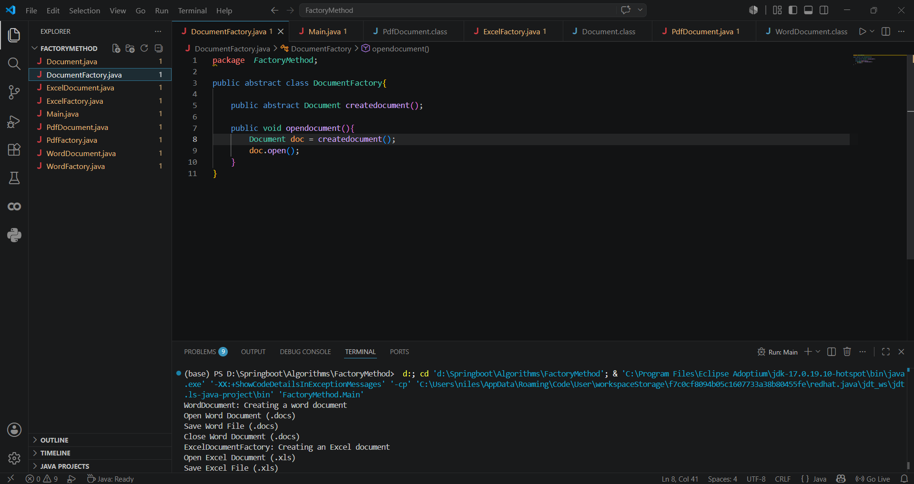

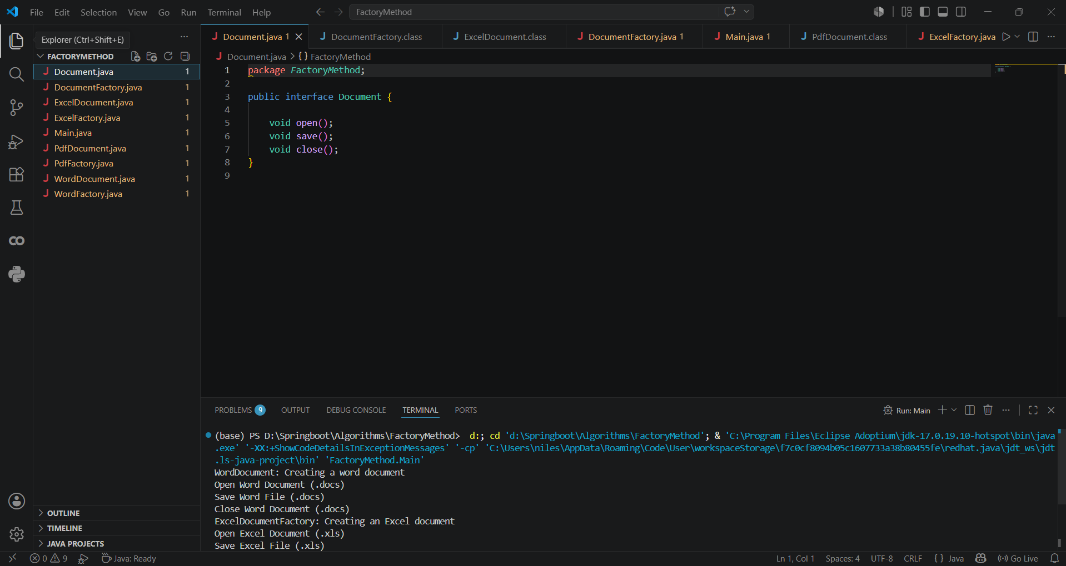
2. Implementing and extending the classes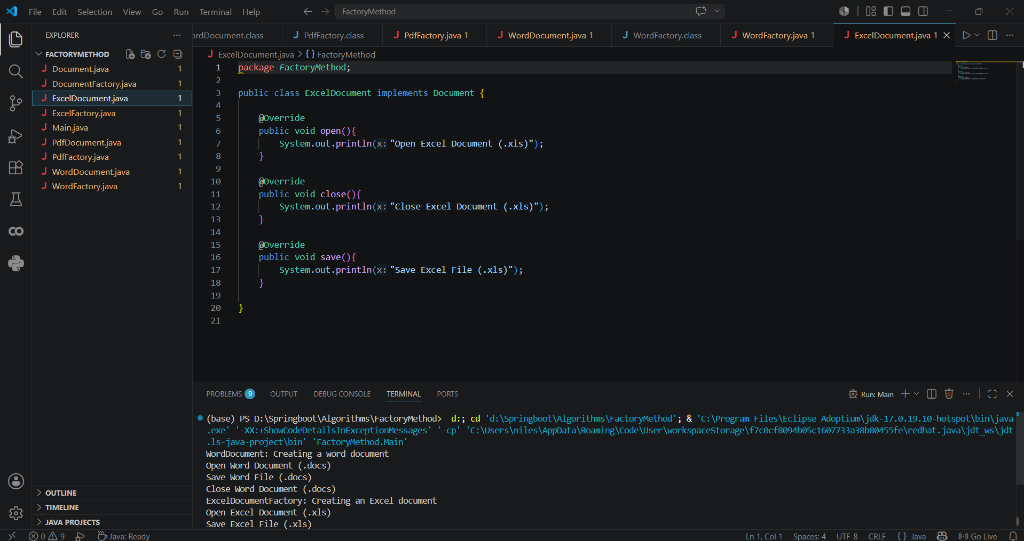

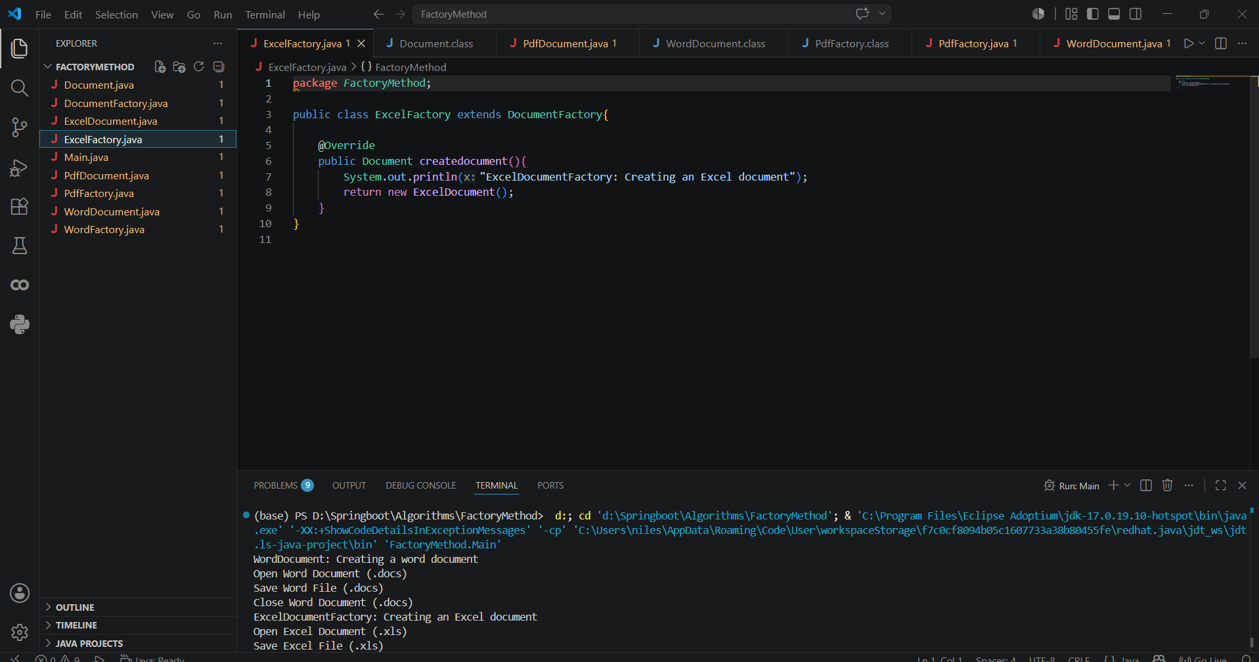

3.Main class with Output
